Driving Convention Using Xbox Controller Joy Stick

# Turning Forward

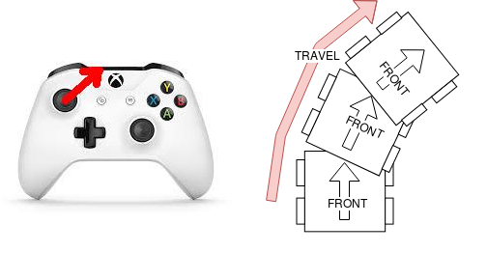  
Illustration 1: Joystick forward-right means robot drives forward and to the right

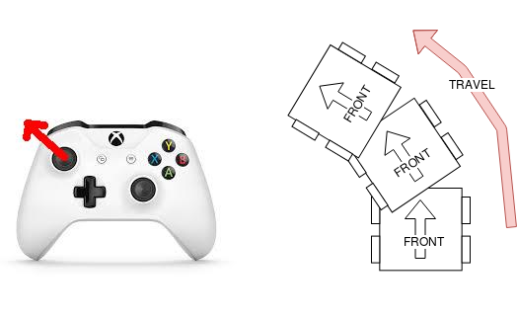  
Illustration 2: Joystick forward-left means robot drives forward and to the left

# Turning Backward

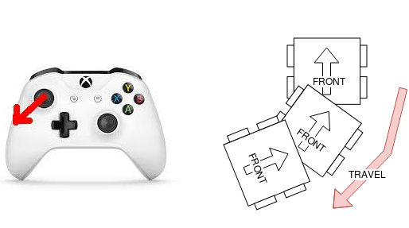  
Illustration 3: Joystick backward-left means robot drives reverse and to the left

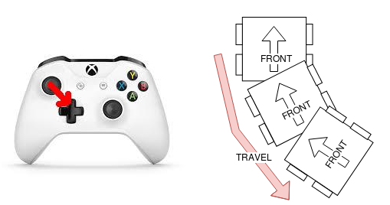  
Illustration 4: Joystick backward-right means robot drives reverse and to the right